POWER PROJECT 1: ZOMATO

- Data Transformation:
- Removed the redundant columns (Longitude & Latitude),
- Removed the null & duplicate values
- Corrected the city names
- Split the column into two parts – ‘Restaurant Name’ and ‘Restaurant Address’

- Created a new table “Restaurant Cuisines’:

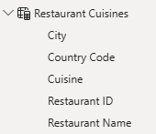

- Created new columns and measures using DAX:
- Continent in the Country table
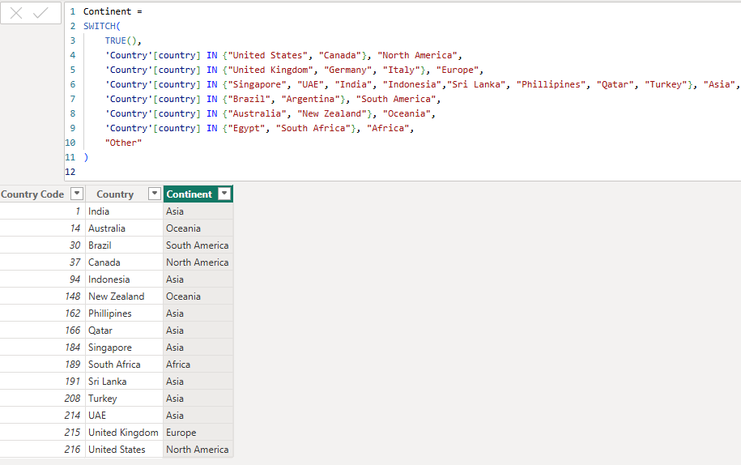
- ‘Rating Color’ in the KPI’s table

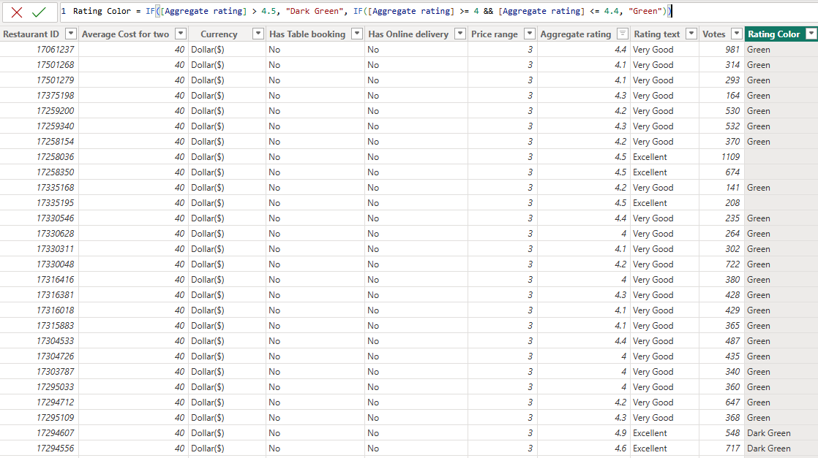

- Measures
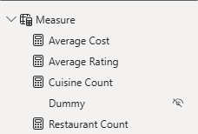

VISUALS:
- Restaurants based on geographical dimensions with Slicer:
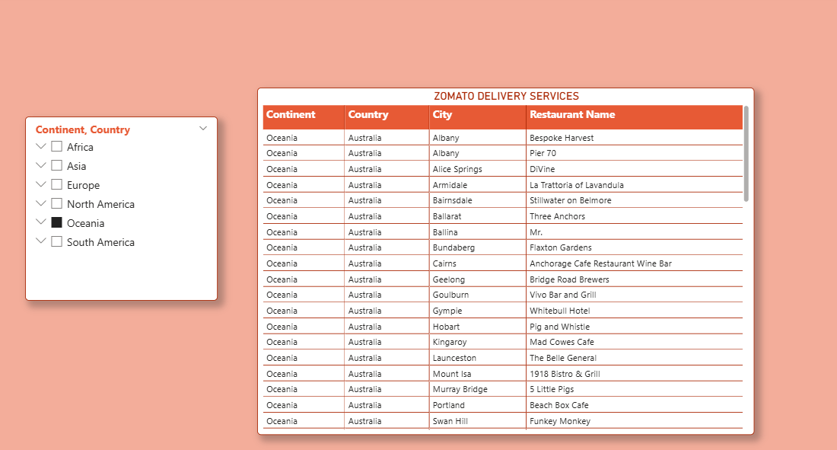

- Restaurants whether or not provide Online ordering/Reservation services:

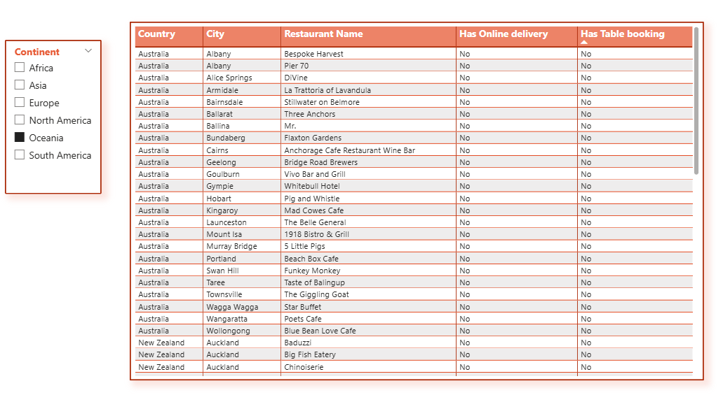

- Restaurant with the Average rating:
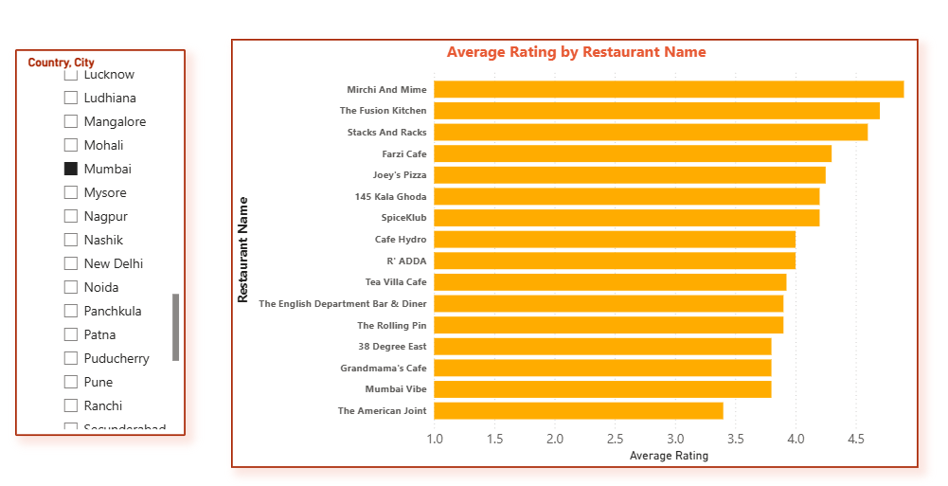

4. Restaurant with the Count of Cuisines: 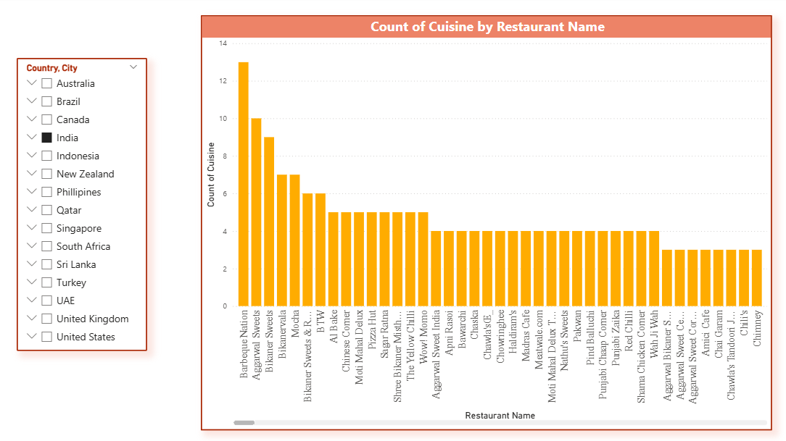

- Restaurants Average Cost: Sorted in Ascending order:
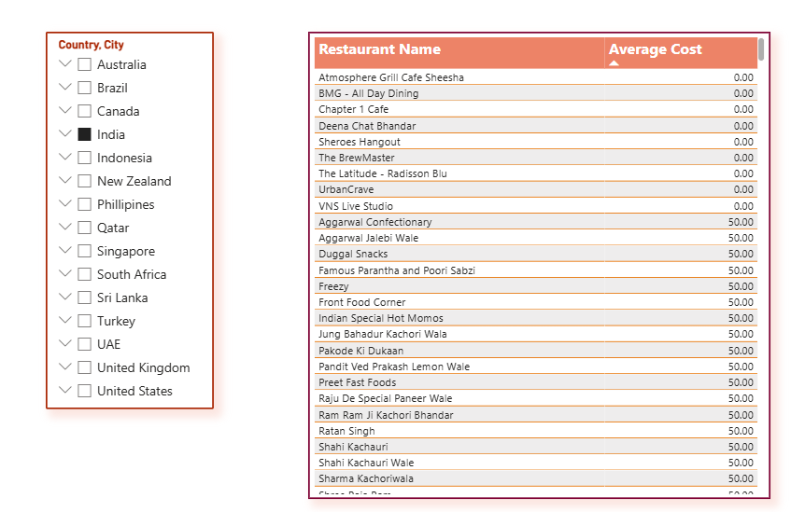

Mobile Layout

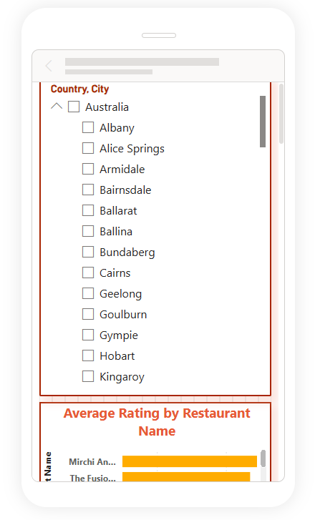

MODEL VIEW:

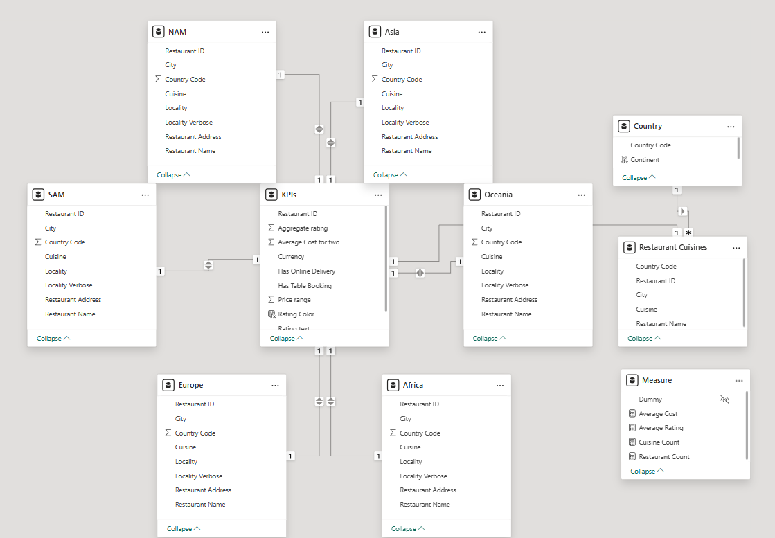

PUBLISH TO POWERBI SERVICE

